* **MAULANA AZAD NATIONAL INSTITUTE OF TECHNOLOGY**

**Name:** Vivek Kumar Ahirwar **Scholar No:** 191112419

**Department:** CSE **Section:**3

**Semester:** 4th **Subject:** PHP Lab

**Date:** 11/02/2020

PHP: LAB-ASSIGNMENT 2

Online Hosted Assignment Link: <http://php-vivek-repo.mywebcommunity.org/>

<http://php-vivek-repo.mywebcommunity.org/StudentControlPanel.php?/>

Code & Output:

*StudentControlPanel.php*

<!DOCTYPE html>

<html lang="en">

<head>

    <meta charset="UTF-8">

    <title>Student Control Panel</title>

    <style>

        .button {

            border: none;

            color: white;

            padding: 15px 32px;

            text-align: center;

            text-decoration: none;

            display: inline-block;

            font-size: 16px;

            margin: 4px 2px;

            cursor: pointer;

            background-color: #008CBA;

        }

    </style>

</head>

<body>

    <h1 align='center'>Welcome to Student Control Panel</h1>

    <br>

    <p>Vivek Kumar Ahirwar</p>

    <p>191112419</p>

    <p>CSE-3</p>

    <br>

    <form action="RollNumberDisplay.php">

        <input class = "button" type="submit" value="Roll Numbers" />

    </form>

    <br>

    <form action="ScoresDisplay.php">

        <input class = "button" type="submit" value="Scores" />

    </form>

    <br>

    <form action="InsertStudentForm.php">

        <input class = "button" type="submit" value="Insert Student" />

    </form>

    <br>

    <form action="GetDetails.php">

        <input class = "button" type="submit" value="Get All Details" />

    </form>

</body>

</html>

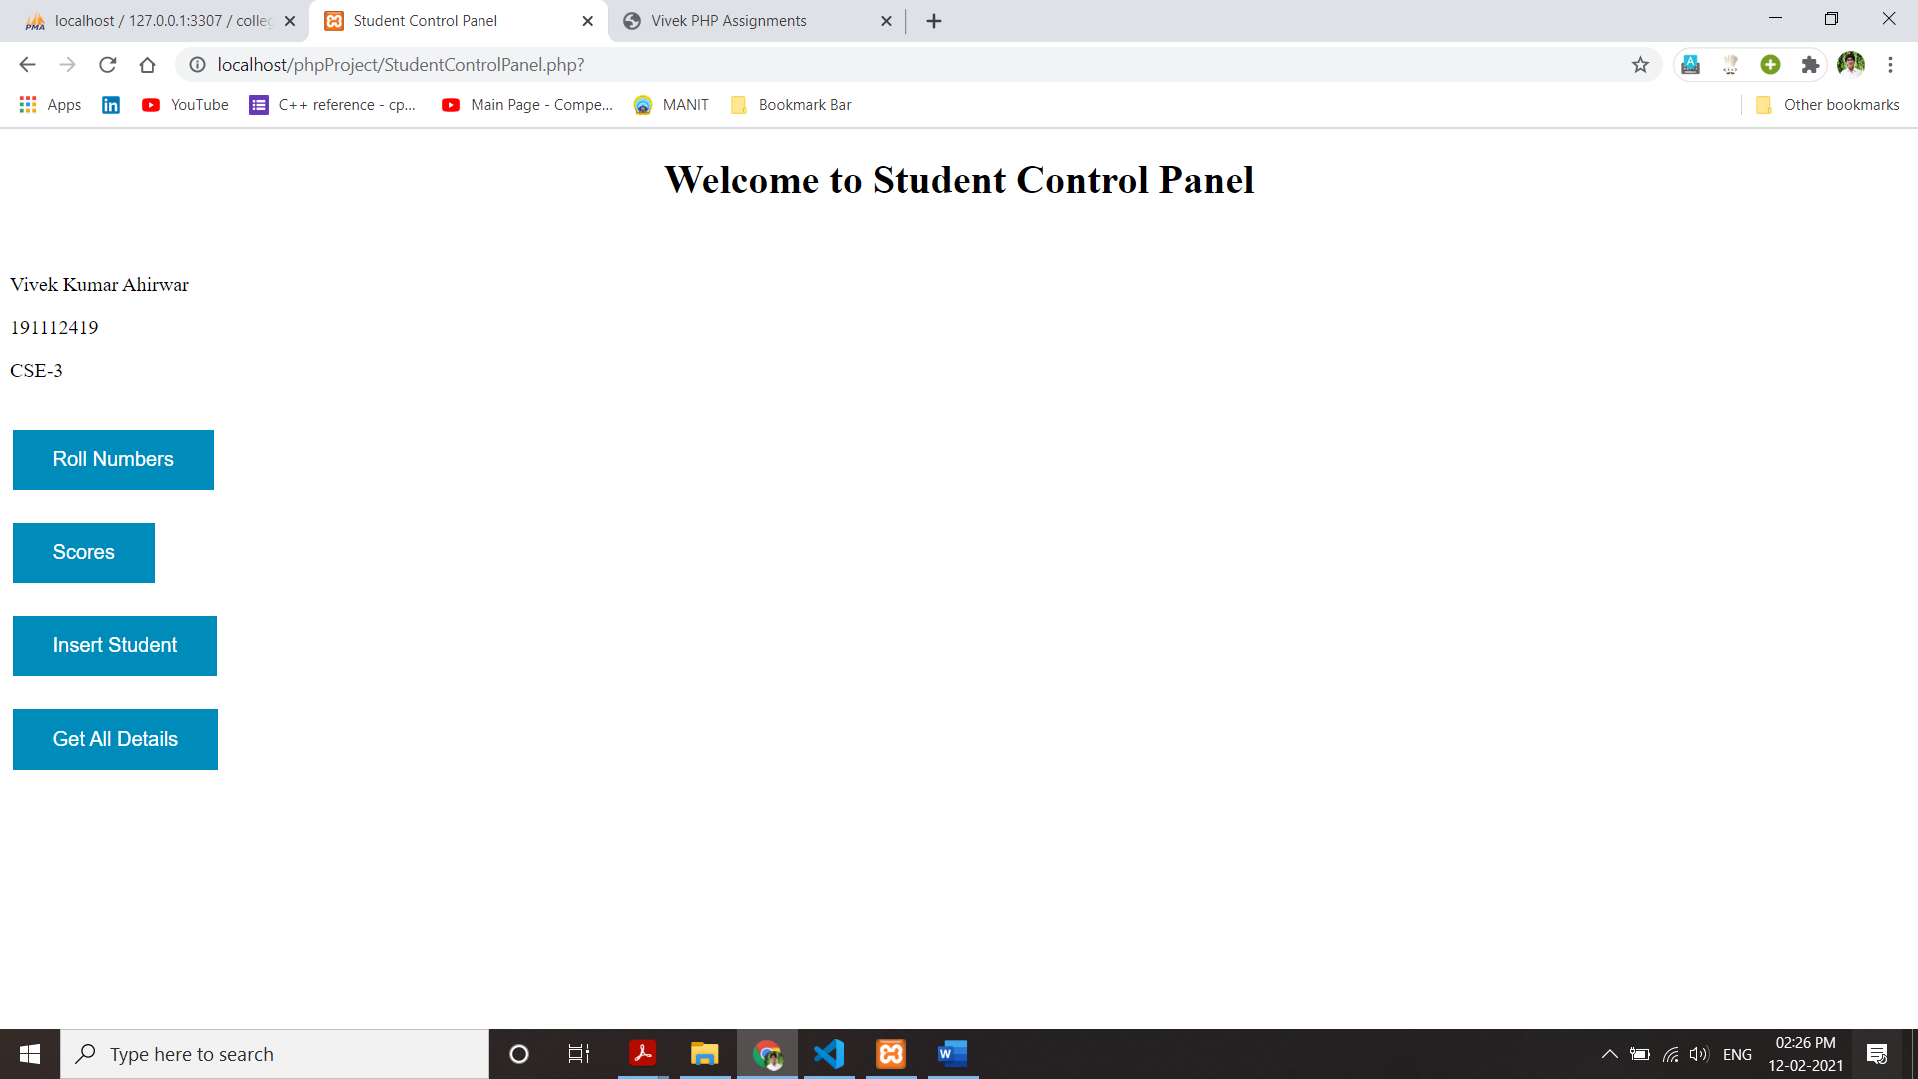

*RollNumberDisplay.php*

<?php

$servername = 'localhost:3307';

$username = 'root';

$password = "";

$dbname = "college";

$con = mysqli_connect($servername, $username, $password, $dbname);

if (!$con) {

    echo "Oops! Server not connected";

}

if (!mysqli_select_db($con, $dbname)) {

    echo "Oops! Databse not connected";

}

*// $rollno =  $_POST['rollno'];*

$query = "SELECT rollno FROM student;";

$result = mysqli_query($con, $query);

if (!$result) {

    printf("Error: %s\n", mysqli_error($con));

    exit();

}

?>

<!DOCTYPE html>

<html lang="en">

<head>

    <meta charset="UTF-8">

    <title>Roll Numbers</title>

</head>

<body>

    <h1>Roll Number List </h1>

    <p>Vivek Kumar Ahirwar</p>

    <p>191112419</p>

    <p>CSE-3</p>

    <br>

    <?php

    echo "<strong>Roll Numbers :</strong><br>";

    while($row = mysqli_fetch_assoc($result))

    {

        echo "". $row['rollno']."<br>";

    }

    ?>

</body>

</html>

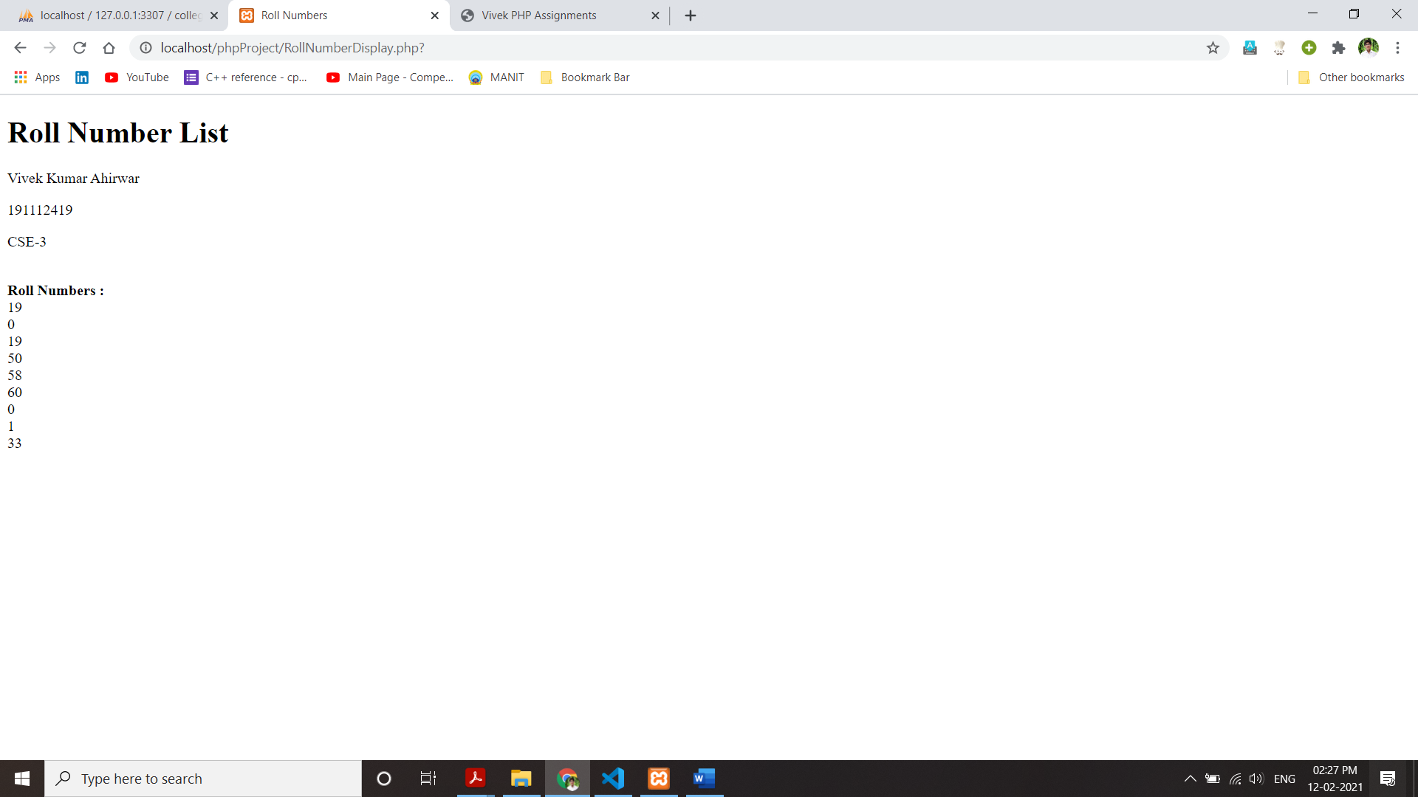

*ScoresDisplay.php*

<?php

$servername = 'localhost:3307';

$username = 'root';

$password = "";

$dbname = "college";

$con = mysqli_connect($servername, $username, $password, $dbname);

if (!$con) {

    echo "Oops! Server not connected";

}

if (!mysqli_select_db($con, $dbname)) {

    echo "Oops! Databse not connected";

}

*// $rollno =  $_POST['rollno'];*

$query = "SELECT rollno,score FROM student;";

$result = mysqli_query($con, $query);

if (!$result) {

    printf("Error: %s\n", mysqli_error($con));

    exit();

}

?>

<!DOCTYPE html>

<html lang="en">

<head>

    <meta charset="UTF-8">

    <title>Scores</title>

</head>

<body>

    <h1>Scores Display </h1>

    <p>Vivek Kumar Ahirwar</p>

    <p>191112419</p>

    <p>CSE-3</p>

    <br>

    <?php

    echo "<strong>Roll Number &emsp; Score</strong><br>";

    while($row = mysqli_fetch_assoc($result))

    {

        echo "Roll Number: ". $row['rollno']." &emsp; Score: ".$row['score']."<br>";

    }

    ?>

</body>

</html>

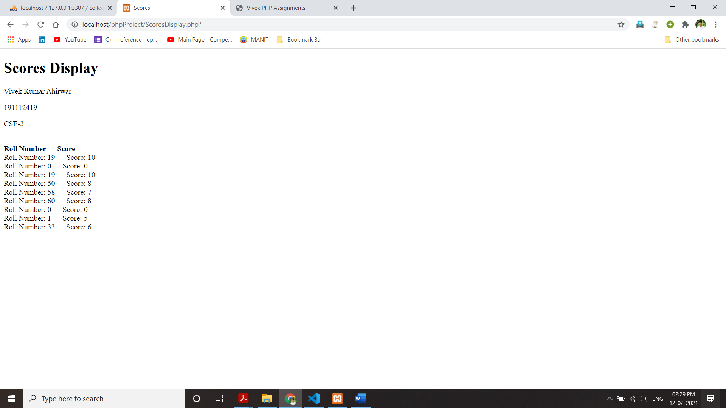

*InsertStudentForm.php*

<!DOCTYPE html>

<html lang="en">

<head>

    <meta charset="UTF-8">

    <title>Add Student Form</title>

    <style>

        .button {

            border: none;

            color: white;

            padding: 15px 32px;

            text-align: center;

            text-decoration: none;

            display: inline-block;

            font-size: 16px;

            margin: 4px 2px;

            cursor: pointer;

            background-color: #008CBB;

        }

    </style>

</head>

<body>

    <h1>Student Form</h1>

    <p>Vivek Kumar Ahirwar</p>

    <p>191112419</p>

    <p>CSE-3</p>

    <br>

    <p>Enter Details of Student</p><br>

    <form action="InsertStudent.php" method='post'>

        Roll Number: <input type="number" name="rollno"><br><br>

        Name: <input type="text" name="username"><br><br>

        Age: <input type="number" name="age"><br><br>

        Score: <input type="number" name="score"><br><br>

        <input class = "button" type="submit" name="submit details"><br><br>

    </form>

</body>

</html>

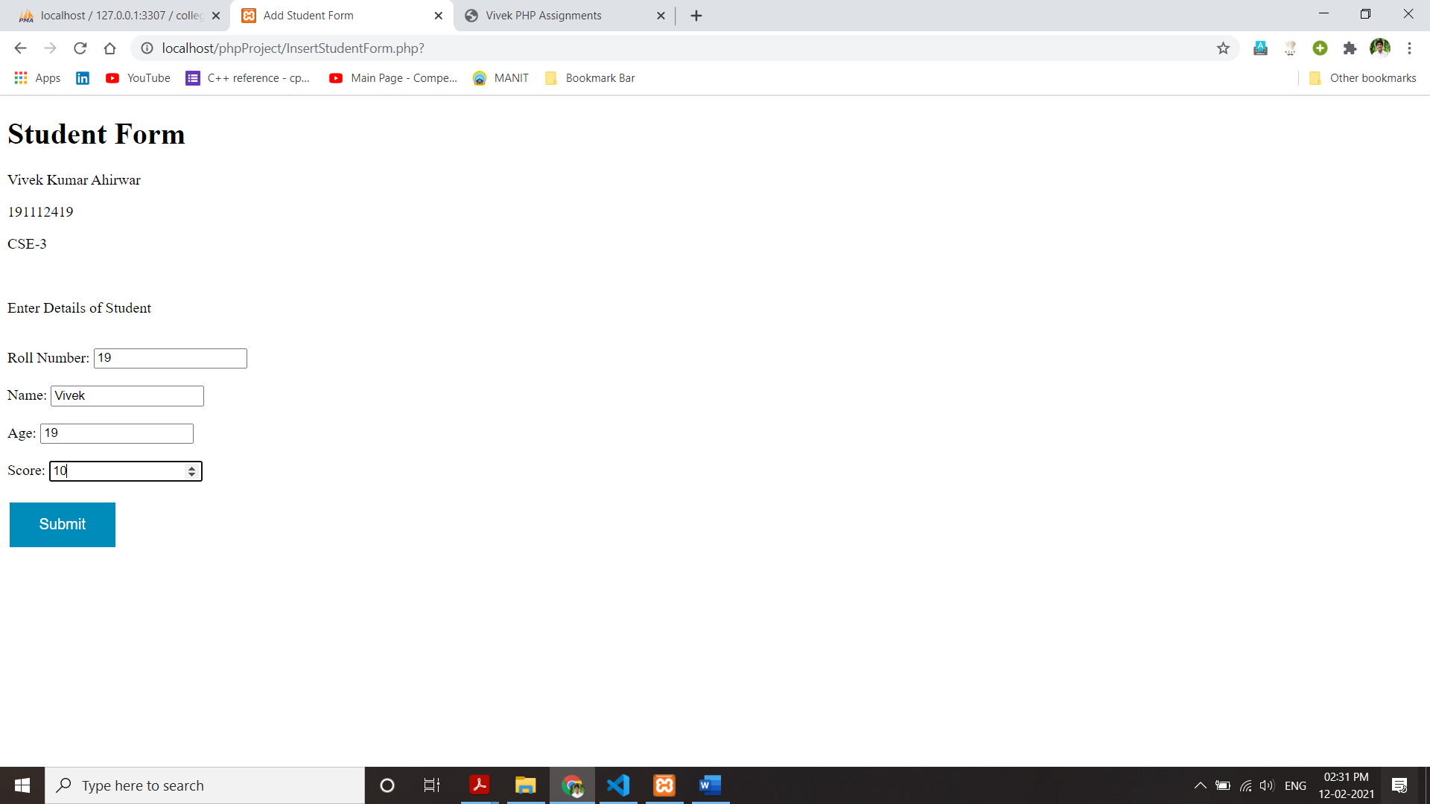

*InsertStudent.php*

<?php

$servername = 'localhost:3307';

$username = 'root';

$password = "";

$dbname = "college";

$con = mysqli_connect($servername,$username,$password,$dbname);

if(!$con)

{

    echo "Oops! Server not connected";

}

if(!mysqli_select_db($con,$dbname))

{

    echo "Oops! Databse not connected";

}

*// echo "database connected<br>";*

$rollno =  $_POST['rollno'];

$name = $_POST['username'];

$age = $_POST['age'];

$score = $_POST['score'];

$query = "INSERT INTO student (rollno,name,age,score) VALUES('$rollno','$name','$age','$score') ;";

if (mysqli_query($con,$query))

{

    echo "<h3>Student Data Inserted Succesfully</h3>";

}

?>



* GetDetails.php*

<?php

$servername = 'localhost:3307';

$username = 'root';

$password = "";

$dbname = "college";

$con = mysqli_connect($servername, $username, $password, $dbname);

if (!$con) {

    echo "Oops! Server not connected";

}

if (!mysqli_select_db($con, $dbname)) {

    echo "Oops! Databse not connected";

}

*// $rollno =  $_POST['rollno'];*

$query = "SELECT * FROM student;";

$result = mysqli_query($con, $query);

if (!$result) {

    printf("Error: %s\n", mysqli_error($con));

    exit();

}

?>

<!DOCTYPE html>

<html lang="en">

<head>

    <meta charset="UTF-8">

    <title>Scores</title>

</head>

<body>

    <h1>All Student Details </h1>

    <p>Vivek Kumar Ahirwar</p>

    <p>191112419</p>

    <p>CSE-3</p>

    <br>

    <?php

    echo "<table border='1'>

    <tr>

    <th>Roll Number</th>

    <th>Name</th>

    <th>Age</th>

    <th>Score</th>

    </tr>";

    while ($row = mysqli_fetch_assoc($result)) {

*// echo "Roll Number: " . $row['rollno'] . " &emsp; Score: " . $row['score'] . "<br>";*

        echo "<tr>";

        echo "<td>" . $row['rollno'] . "</td>";

        echo "<td>" . $row['name'] . "</td>";

        echo "<td>" . $row['age'] . "</td>";

        echo "<td>" . $row['score'] . "</td>";

        echo "</tr>";

    }

    echo "</table>";

    ?>

</body>

</html>

